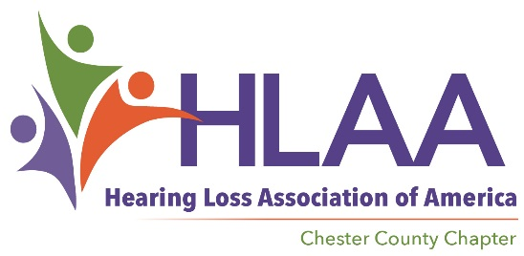
hlaachesco@gmail.com - 484-402-4907 - www.hearinglosschesco.com

Chapter Meeting
Wednesday, March 14, 2018

Welcome/Get Acquainted/Snack and Social Time
Attendance - 12

Administrative Business
- Budget/Treasurer’s Report - Steve Shugarts
Treasurers Report
Prior Month-Account balance $ 5443.23
Income $ 30
Expenses $ 120
Current Acct. Balance $ 5353.23
Electronics Earmarked* $ 1314 (Outstanding 2017 $58.70)
Net Operating Balance $ 3980.96

Information Update
  - HLAA - Pennsylvania State Office www.hlaa-pa.org
    - HearSay Newsletter – encouraging electronic rather than print; need funds to continue; walk share $2,092.00
Walk4Hearing – 2017 results very good; almost $143,000 raised; our share should be around $3,361.60. Plans are being made for 2018.
  - National HLAA Office www.hearingloss.org
    - Convention – Minneapolis MN June 21-28, 2018
    - Bill Best won the Community Service award!

Old Business
- Facebook/Website/Email Update - Carolyn
- Chapter Transition
  - President (Bill Pfeifer – interim)
  - Secretary (Carolyn Best – leaving by May 2018)
  - Judy Shugarts will handle some of Carolyn’s functions.
  - Vice President – Rick Shinners has agreed to undertake this important role
New Business
- Upcoming Events – VOLUNTEERS NEEDED
- Hearing Loss Student Scholarship – need to plan for this year’s recipient
  - Eagles football raffle – Kim Ginsberg, ABC Hearing, shared $700 raised.
    - HLAA CC will add money to make the scholarship $1000
  - The winner was Art Passic and will pick up the football at ABC Hearing
  - 6 scholarship candidates are in contention
- Speakers/Topics Ideas for 2018
  - March – WCU speaker Dr Aaron Roman; WCU Speech and Hearing Clinic overview.
  - April – Don Groff; topic is "Dealing with Hearing Loss in Public Spaces"
  - May – Innocaption smart phone captioning app / Acupuncture presentation
  - June – ice cream social and awarding of second annual scholarship

Any other business
  - Guest Speaker - Dr Aaron Roman; Aaron M. Roman, Au.D. CCC-A, F-AAA
Assistant Professor, Department of Communication Science & Disorders
West Chester University, 201 Carter Drive, Suite 400
Office Phone: (610) 436-3436, Email: aroman@wcupa.edu

Overview of WCU Speech and Hearing Clinic
Powerpoint of presentation will be posted on website.

Next Meeting will be Wednesday, April 11 @ 7pm

